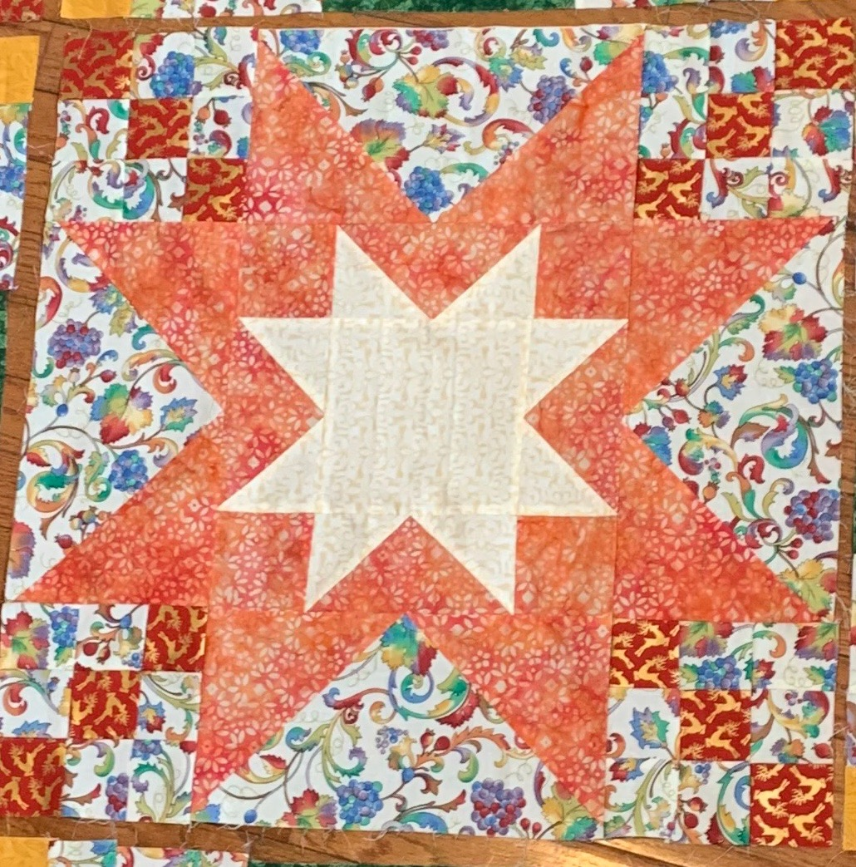
ACPQG Mystery Quilt 2020
Assembling the Quilt Top
February, 2020

*Square up all blocks before assembly.
* Adjust how seams are pressed to reduce bulk where seams meet.

Center Medallion
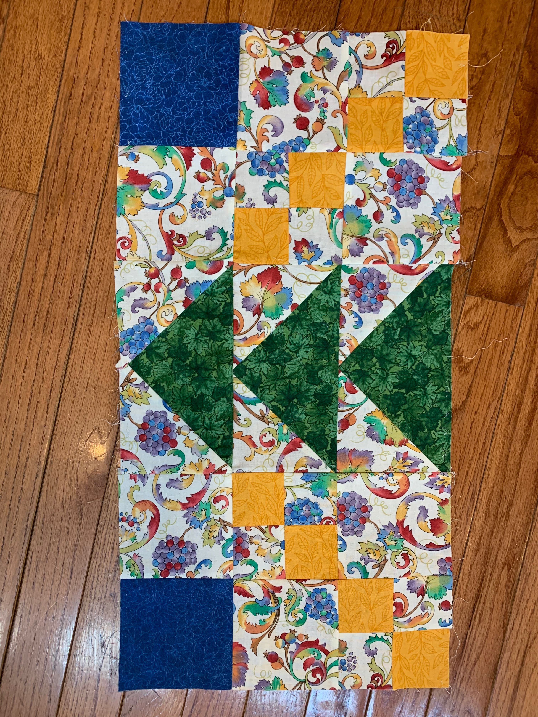
- Sew a flying geese (use 2 of the 4 largest flying geese with background fabric and Fabric B (FB)- 6½“ x 6½“)to opposite sides of the star block (12½” x 12½“) so that the point of the flying geese is pointed toward the star. Press the seams away from the star.
Center Medallion
- Sew a 9 patch block made with FE to each end of the remaining 2 large flying geese with the diagonal block of FE attached at the side of the point of the flying geese. See picture 1. Press the seams toward the flying geese.
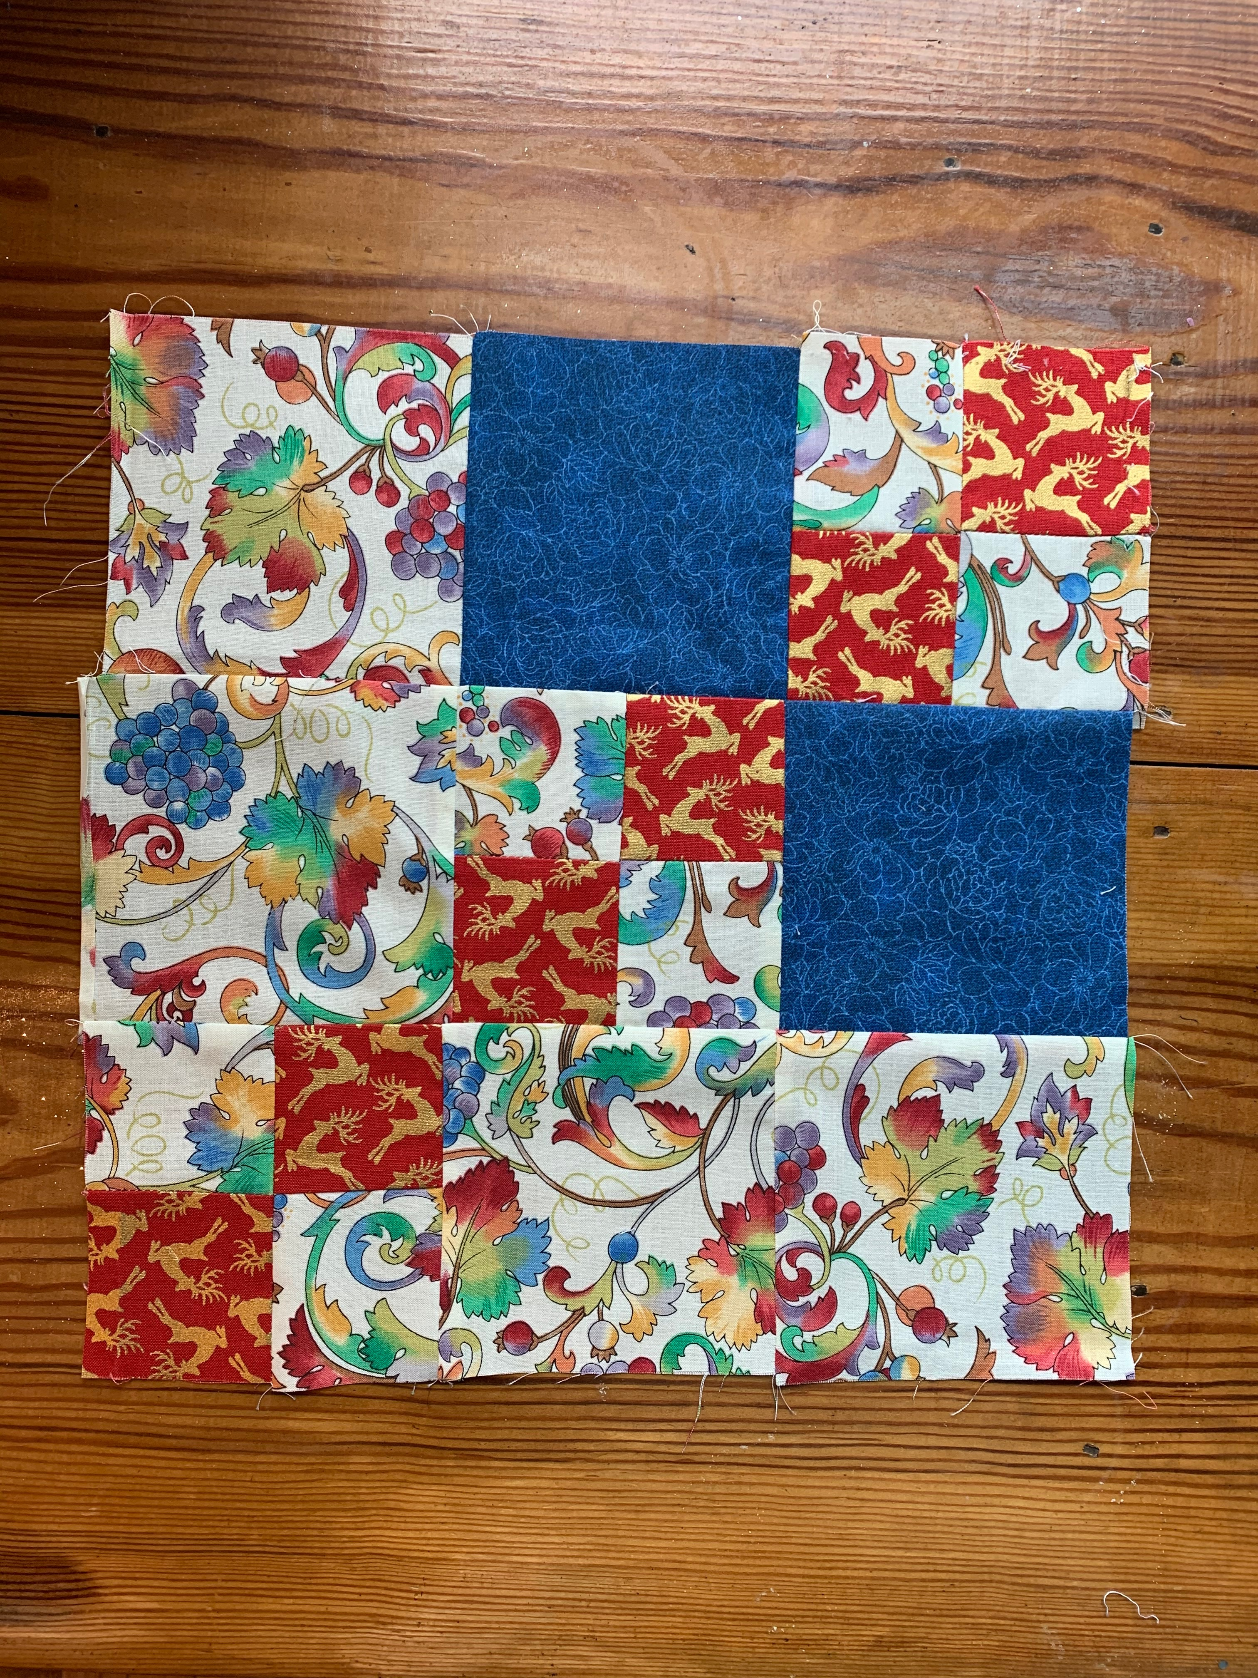
- The two strips are sewn on the remaining opposite sides of the star block, with the point of the flying geese pointing to the center star. You should now see a star in a star with the 9 patch block diagonal radiating out toward the corners. See picture 2

Side Units
Sew a 4 patch block (made from 2 small 4 patch blocks with (FC) and 2 background squares) to either side of the 2 flying geese blocks. The FC in the 4 patch that touches the center flying geese block should be on the point side of the triangle and the FC in the 4 Patch farthest from the flying geese should be on the side of the strip with the base of the triangle. See picture 3. Make 4 Side Units.
Side Unit

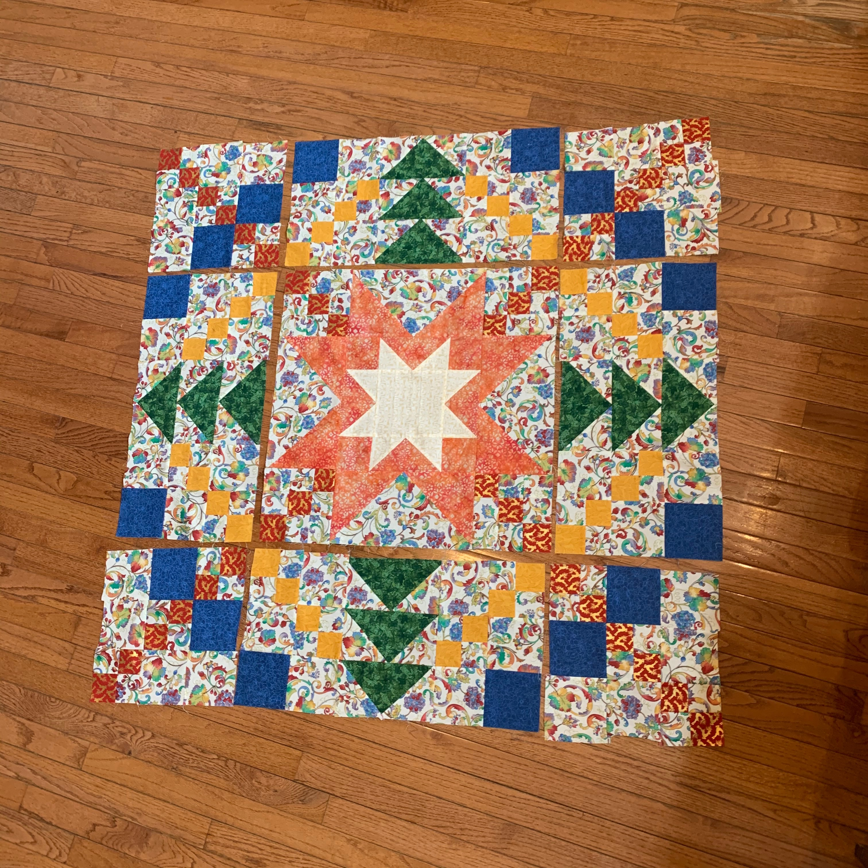
Corner Units
You will assemble 4 Corner Units that are essentially a
9 patch block. Each Corner Unit is made from 2 squares of FD, 3 4 patch blocks of background fabric and FE, and 4 squares of background fabric. See picture 4 to see how the blocks in the Corner Units are arranged.
Corner Unit

Assembly
1. Sew 2 of the Side Units to opposite sides of the center
medallion.
2. Sew 2 Corner Units to each end of each of the Side
Units making sure the diagonal formed from FE lines up
Assembly Layout
with the FE blocks in the center medallion. See picture 5.

